**Module Name:- Continue**

**Test Case ID:- Gpt_01**

**Webpage URL:-**[**https://auth.openai.com/log-in**](https://auth.openai.com/log-in)

**Test Scenario:-Checking that after entering the correct username and password, the user can Continue.**

* **Test Case ID:- TC01**
* **Title :- Verify Continue page loads successfully**
* **Test Steps:-**

**1.Open ChatGPT login URL**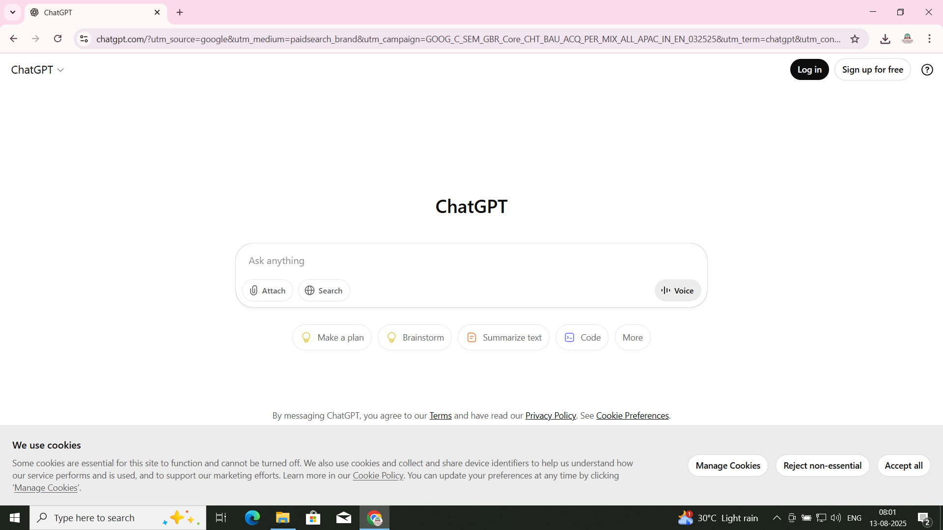

* **Test Case ID:- TC02**
* **Title :- Continue with valid email and password**
* **Test Steps:-**

**1.Enter correct credentials**

**2.Click Continue**

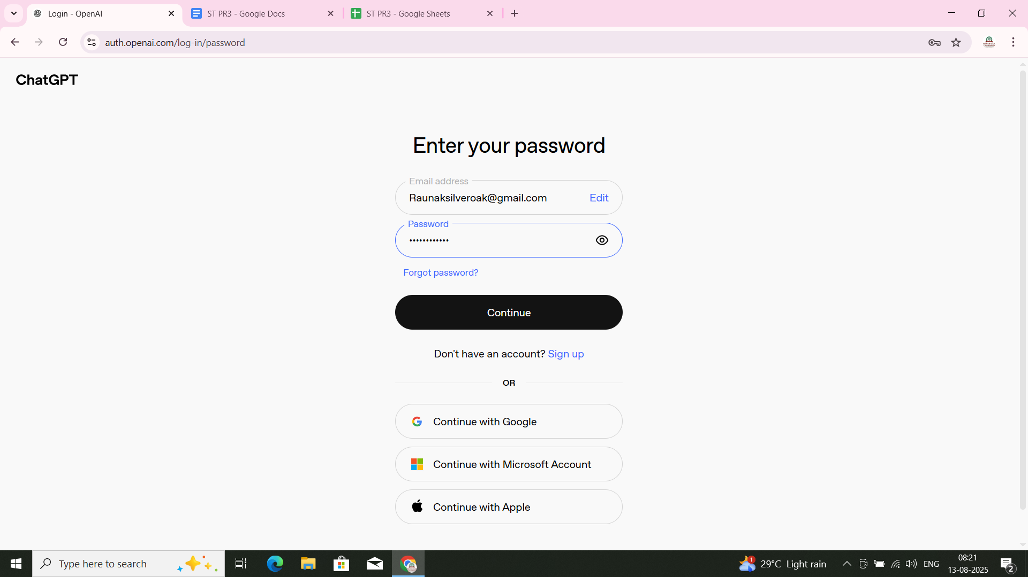

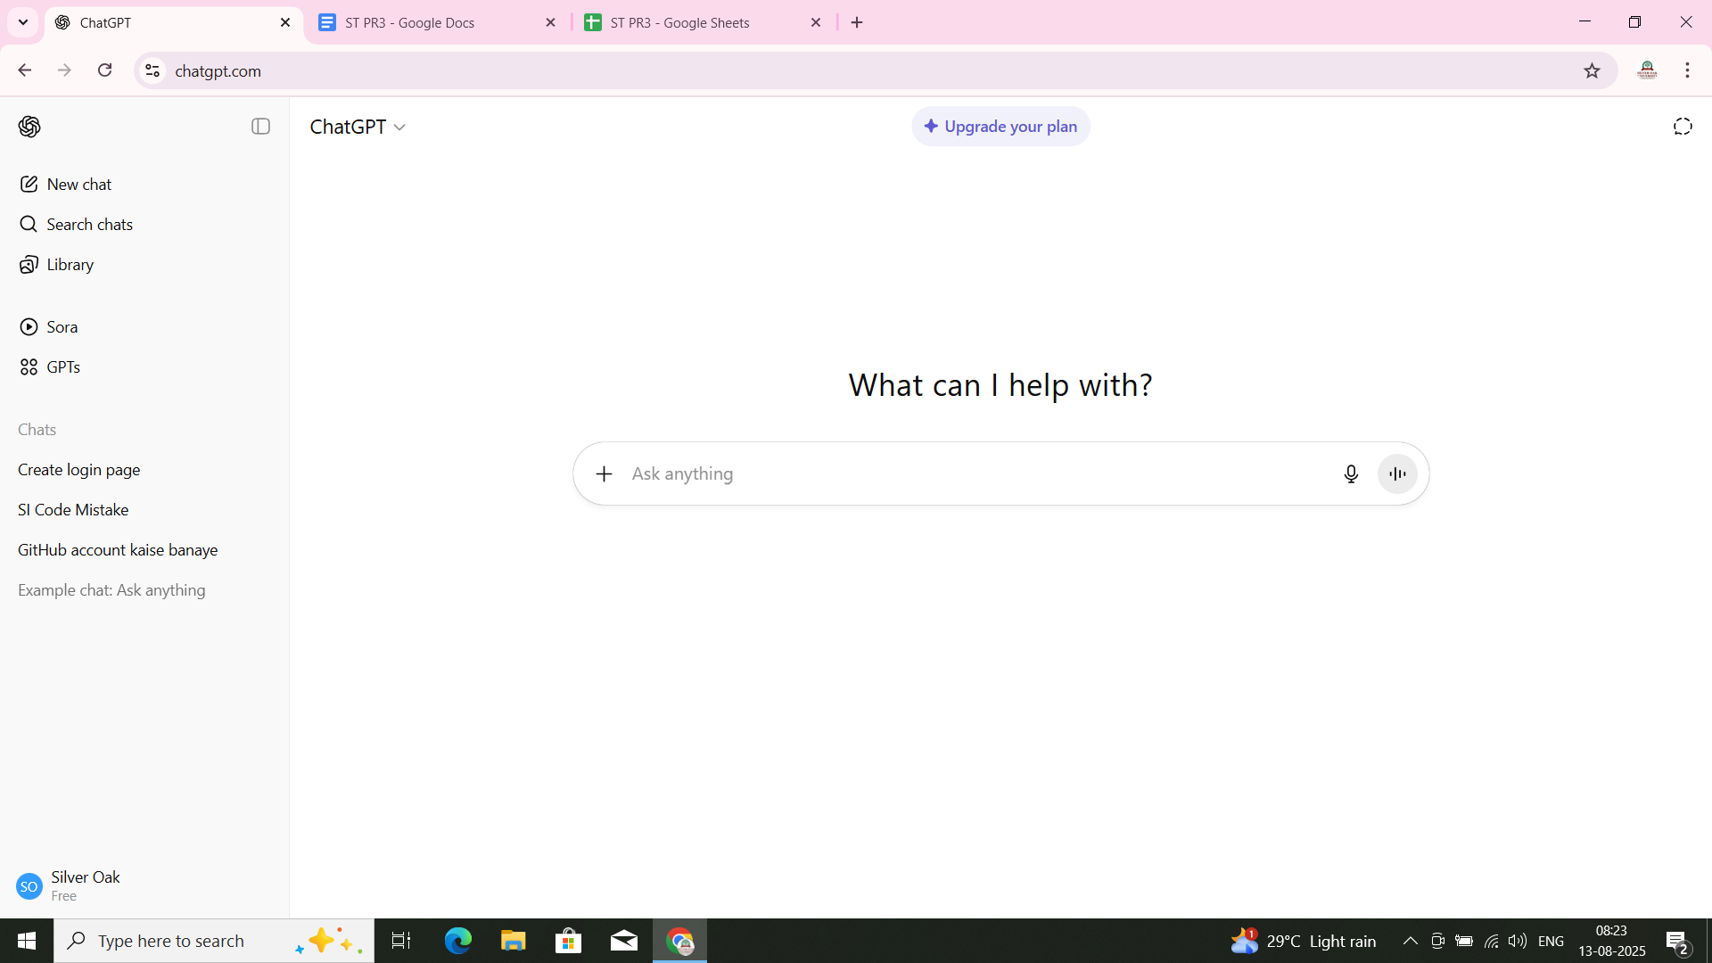

* **Test Case ID:- TC03**
* **Title :- Continue with invalid email format**
* **Test Steps:-**

**1.Enter abc.com**

**2.Click Continue**

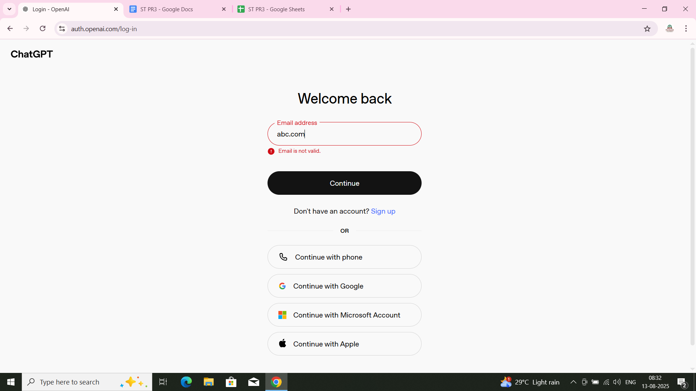

* **Test Case ID:- TC04**
* **Title :-Continue with correct email & wrong password**
* **Test Steps:-**

**1.Enter correct email**

**2. Enter wrong password**

**3.Click Continue**

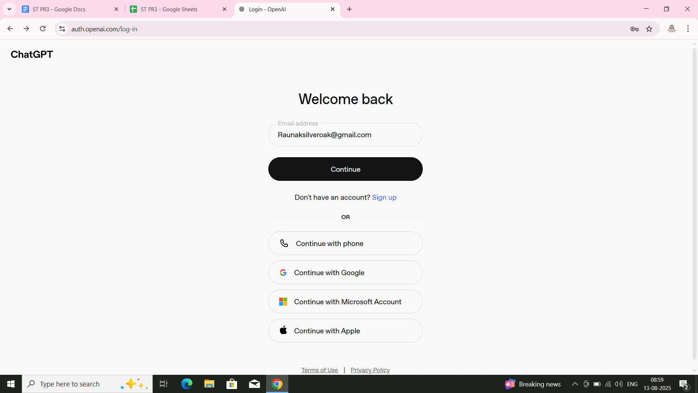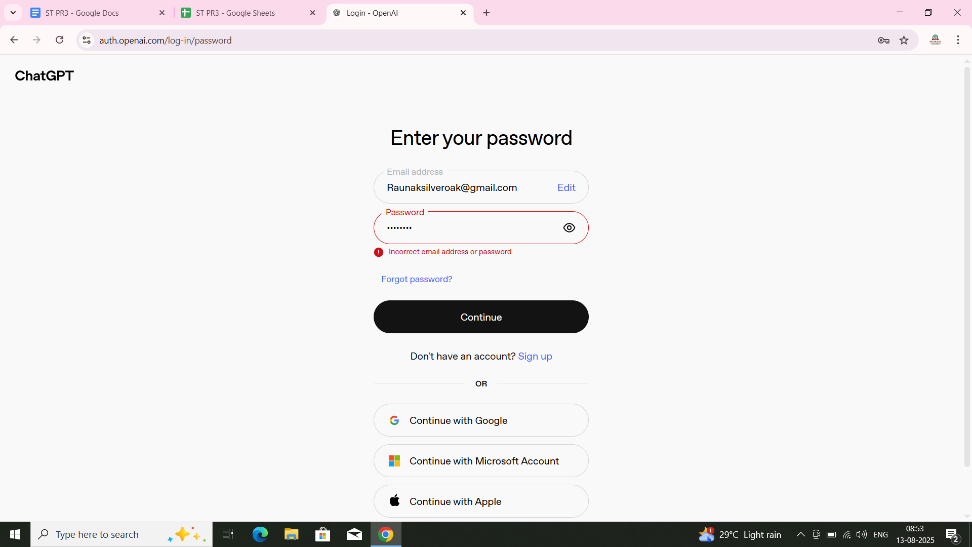

* **Test Case ID:- TC05**
* **Title :-Continue with empty email**
* **Test Steps:-**

**1.Leave email field empty**

**2.Click Continue**

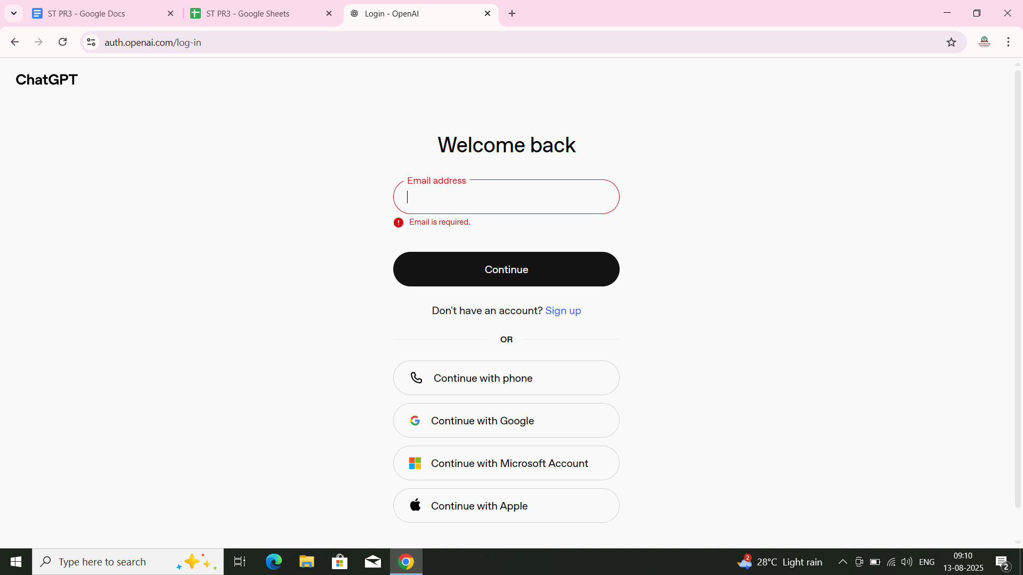

* **Test Case ID:- TC06**
* **Title :-Check password masking**
* **Test Steps:-**

**1.Type password in input field**



* **Test Case ID:- TC07**
* **Title :- Click 'Forgot Password' link**
* **Test Steps:-**

**1.Click on ‘Forgot Password’**

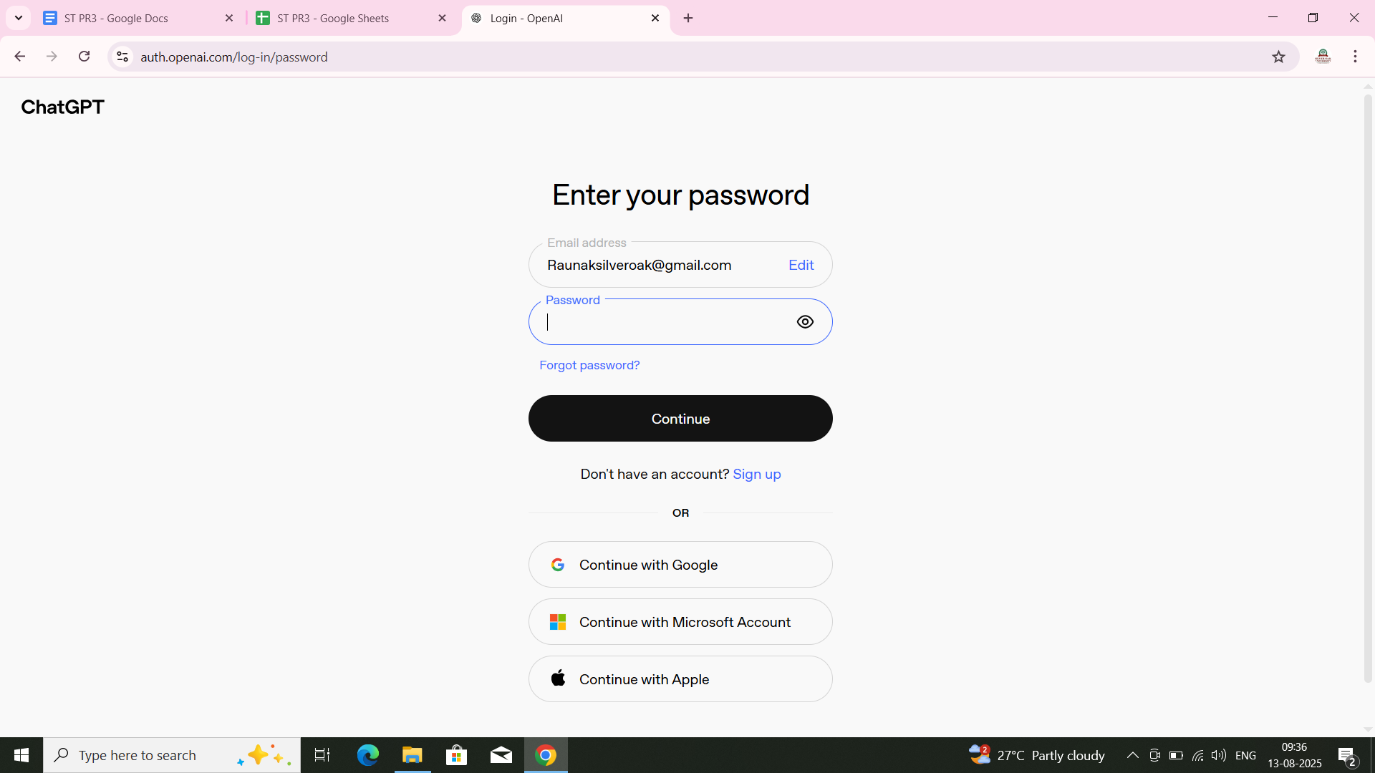

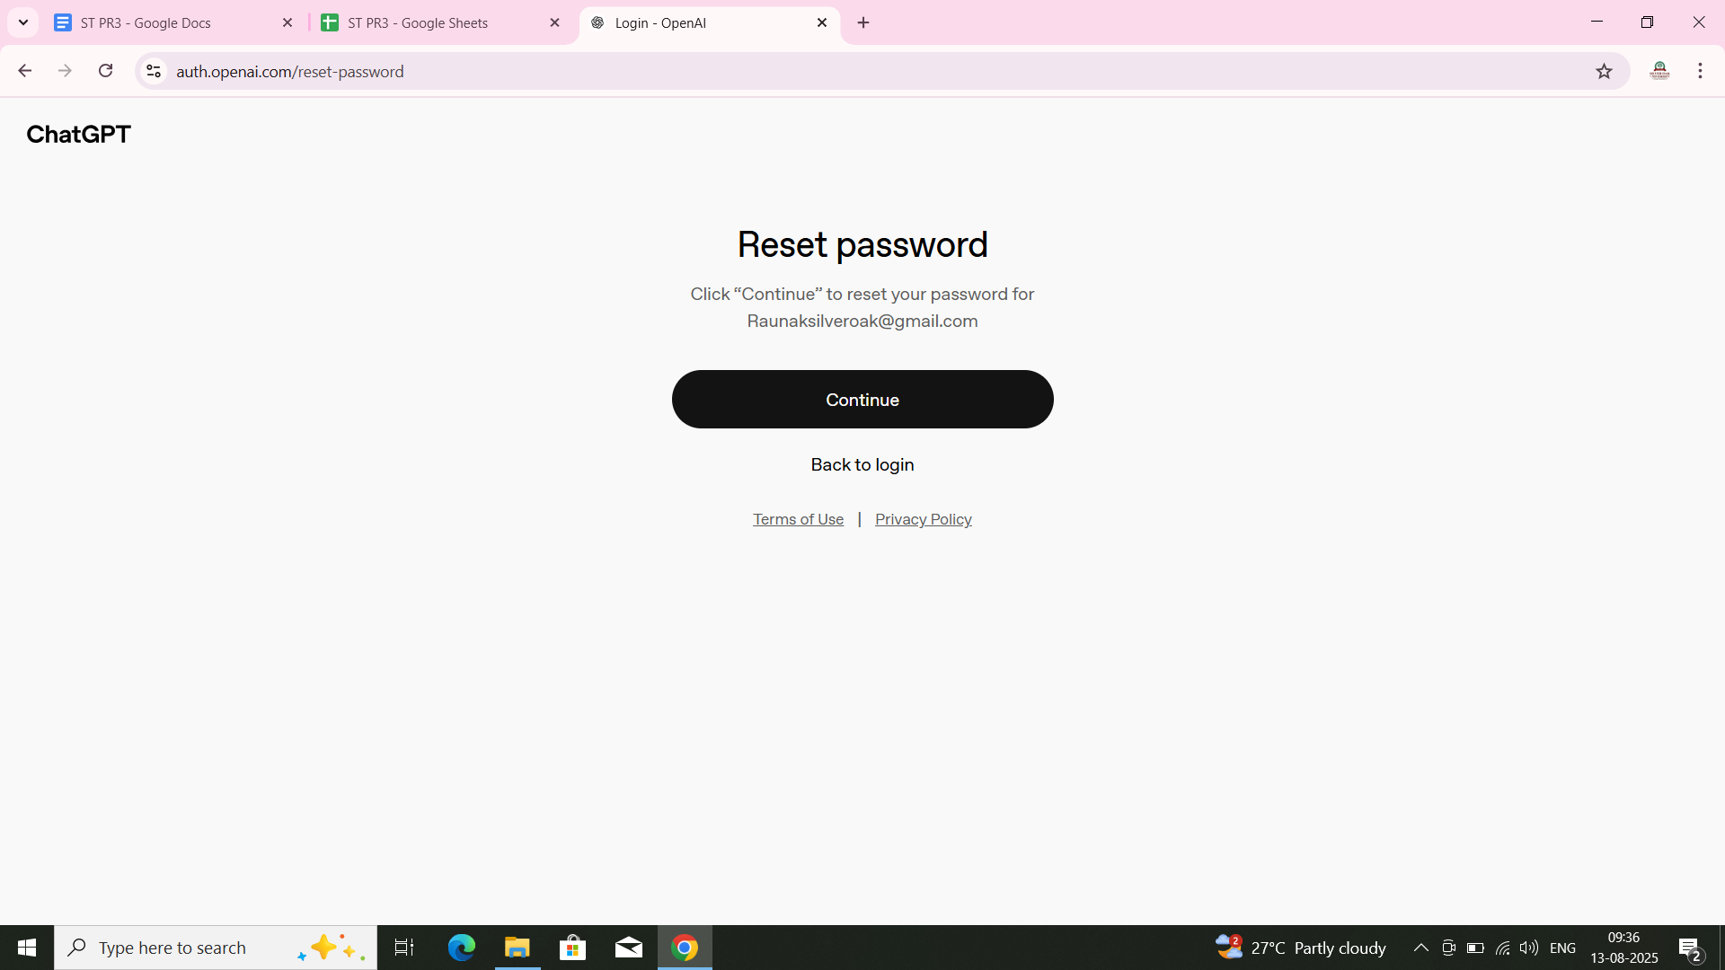

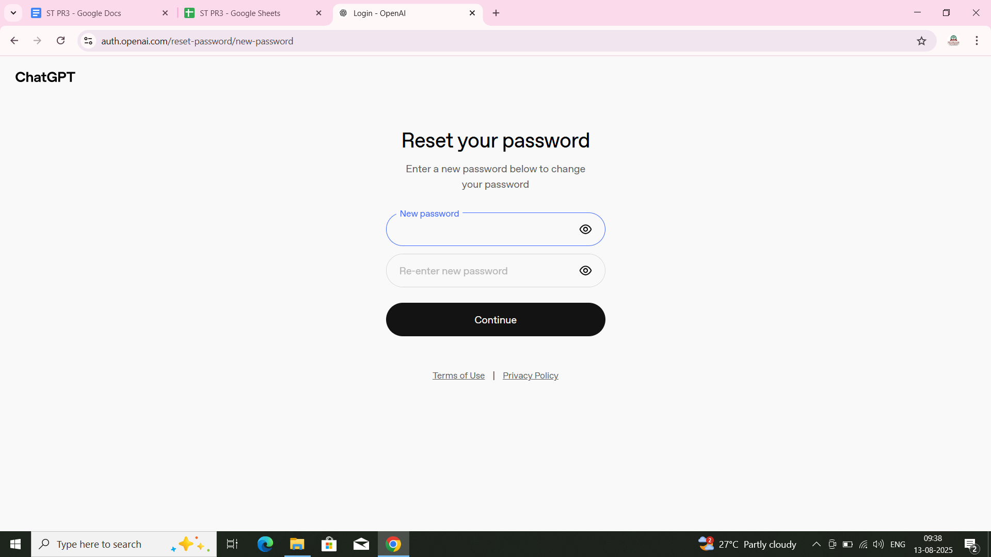

* **Test Case ID:- TC08**
* **Title :- Enter special characters in email**

**Test Steps:-**

**1.Enter !#$%^&*()**

**2. Click Continue**

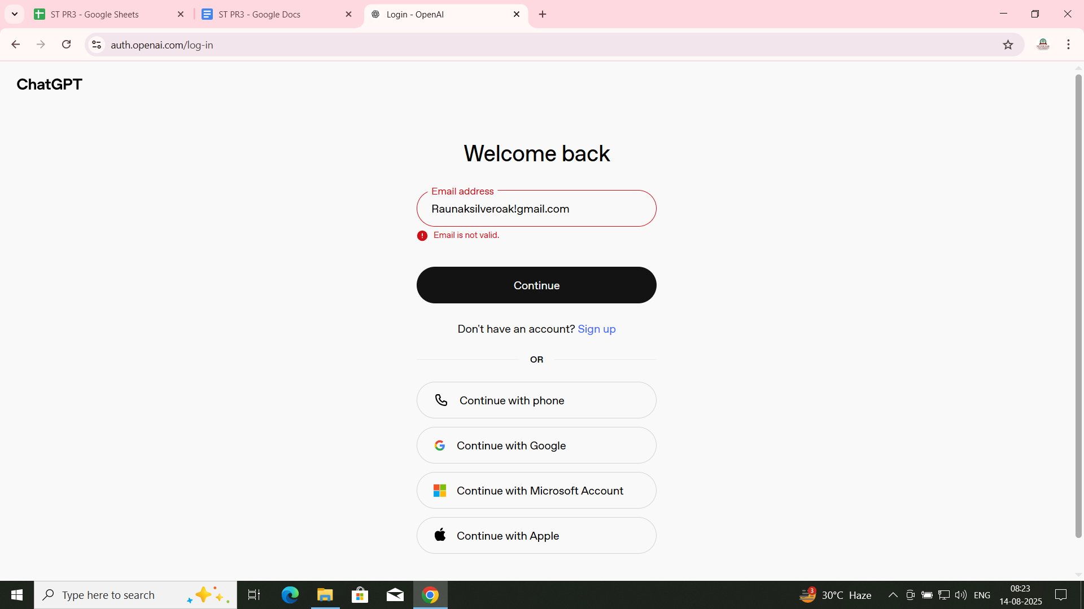

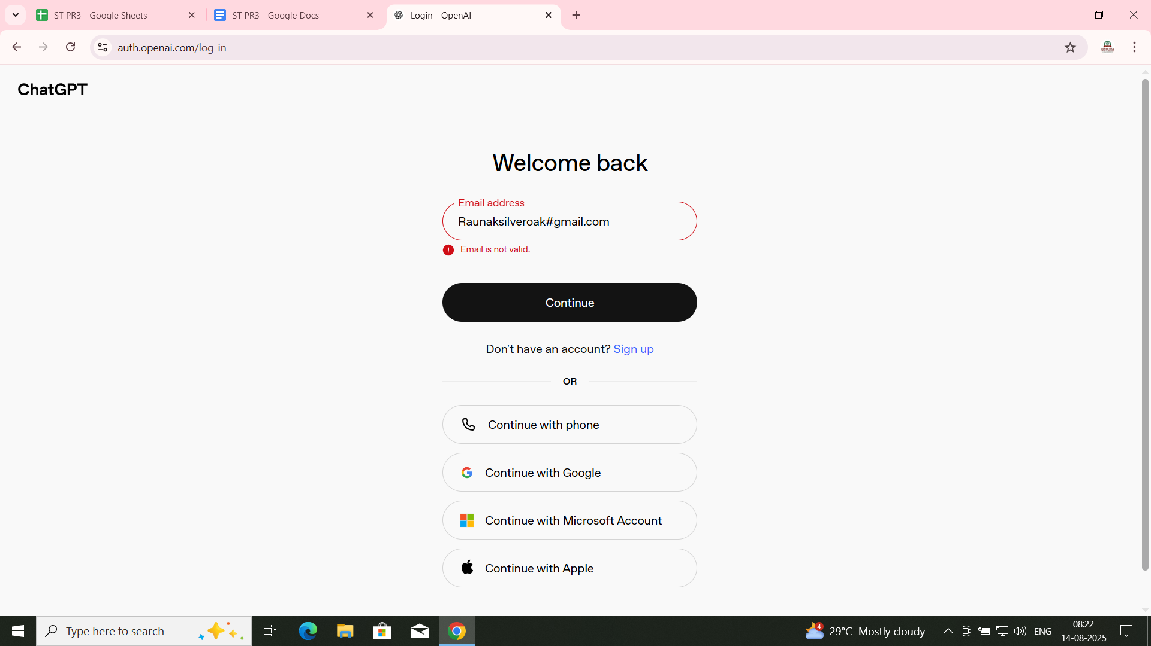

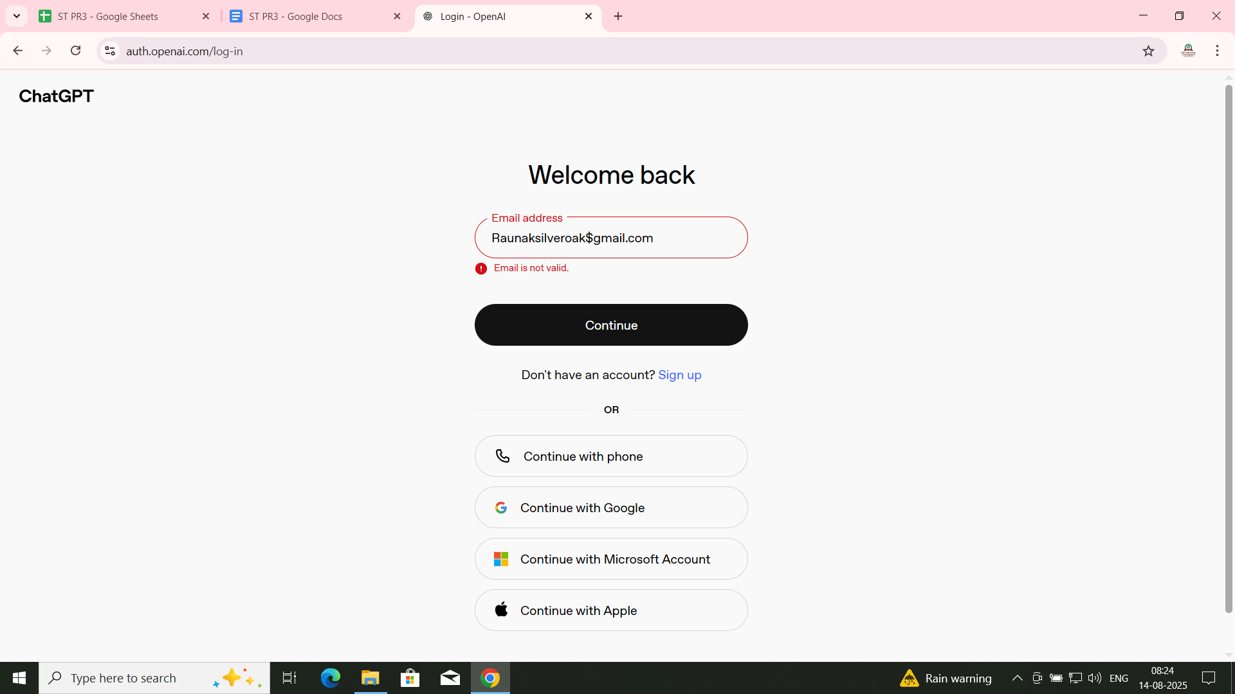

* **Test Case ID:- TC08**
* **Title :- Multiple device login check**

**Test Steps:-**

**1.Login on mobile + desktop**

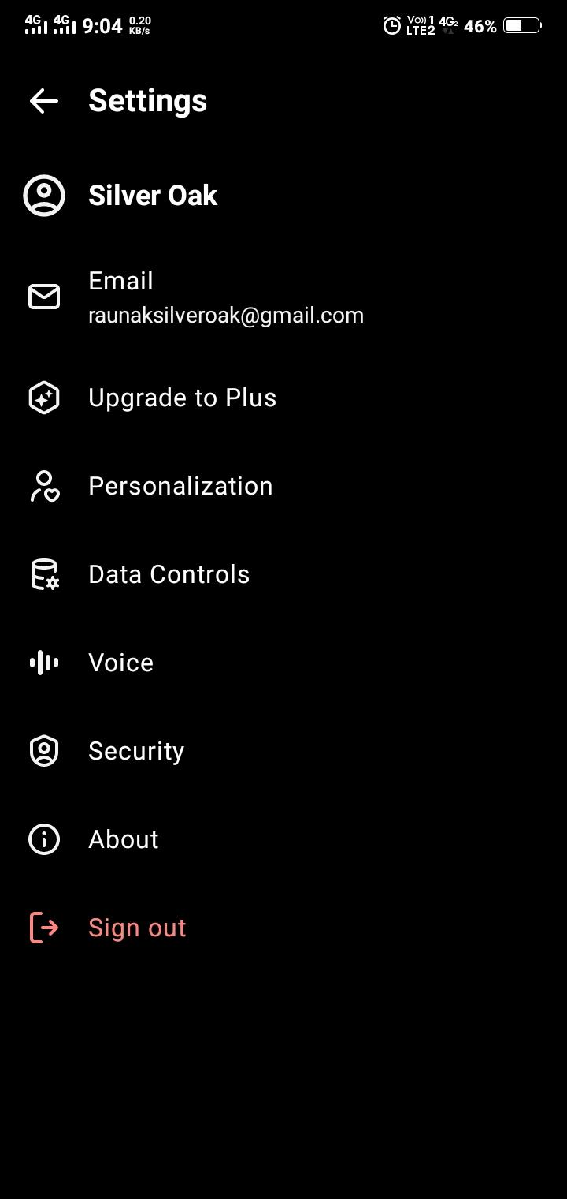

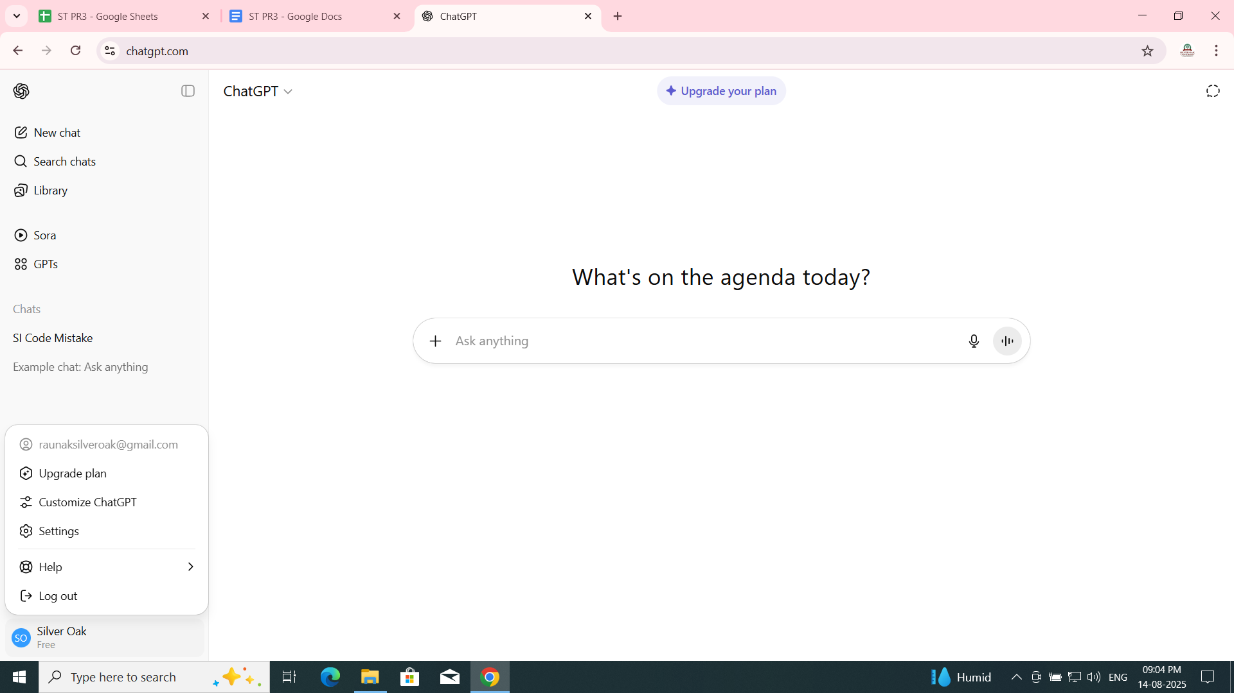

**BUG REPORT**

**Bug ID:- BUG-CHGPT-001  
 Title:- Login button remains active even when email and password fields are empty  
 Reported By:- Raunak Kumar Singh  
 Reported On:- 5th August 2025  
 Module:- Login Page  
 Severity:- Medium  
 Priority:- High**

* **Environment:-**
* **Browser:- Google Chrome v117**
* **OS:- Windows 10**
* **Pre-condition:-**
* **User is on ChatGPT login page**
* **Steps to Reproduce:-**

1. **Open ChatGPT login page**
2. **Leave both email and password fields empty**
3. **Observe the Login button**

* **Expected Result:-**
* **Login button should remain disabled until required fields are filled**
* **Actual Result:-**
* **Login button remains active even when fields are empty**

**Status:- New  
 Screenshot:-**

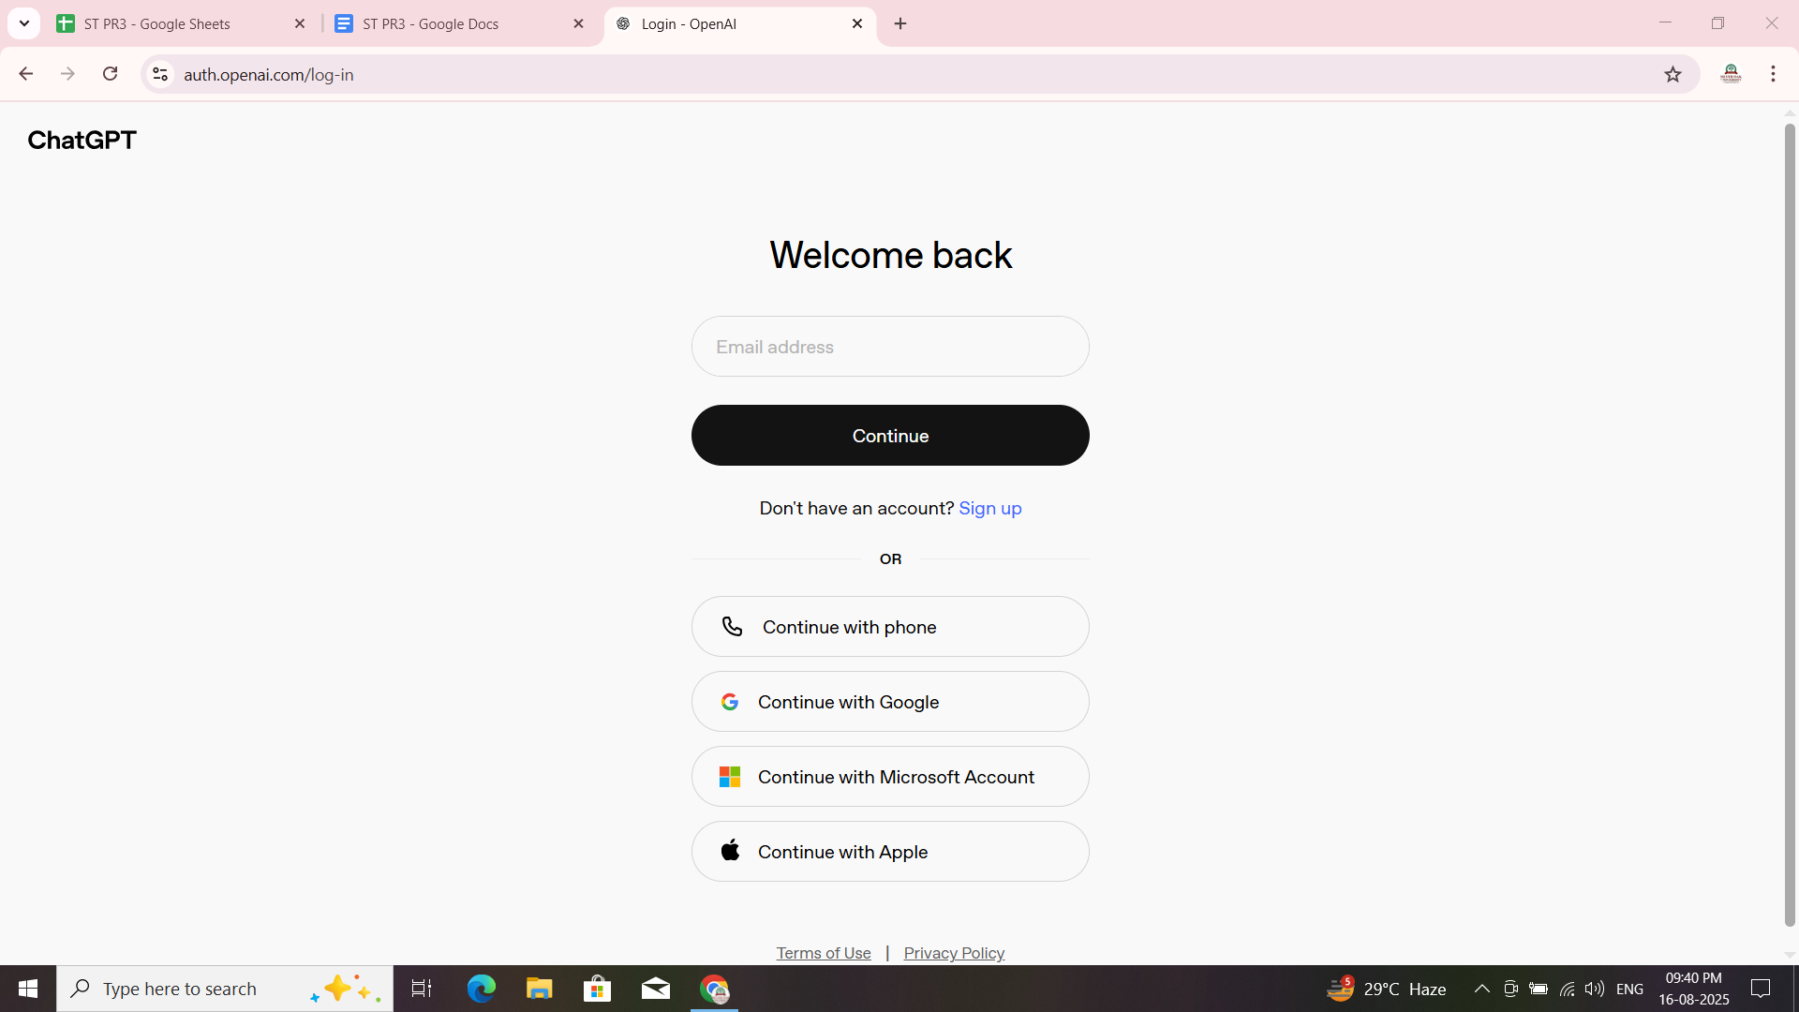

**Comment:-This may lead to unnecessary login attempts and poor user experience. Basic field validation should be added.**